Report of the Event

Number of the activity | 7
Title of the activity | National seminar about seeds and plant reproductive material regulation. "Current state and situation in the EU"
Organisation | Red de Semillas “Resembrando e Intercambiando” (RdS) and Coordinadora de Organizaciones de Agricultores y Ganaderos (COAG).
Size of the organisation
A/ Staff and Board of Directors | - RdS: 27  - COAG: 10
B/ Trainees | - RdS: 20  - COAG: 20
Date of the activity | 17/01/2014
Duration of the activity | 1 day
Place of the activity | C/ Agustín de Bethancourt 17-8ºp. Madrid, Spain
Number of participants and partners | - 1 member of Arche Noah (Austria).  - 1 member of Réseau Semences Paysannes (France).  - 1 member of Resau Semences Paysannes (France) and Vía Campesina Europe (EU).  - 2 members of Red Andaluza de Semillas “Cultivando Biodiversidad” (Spain).  - 20 members of Red de Semillas “Resembrando e Intercambiando” (Spain).  - 15 members of COAG (Spain).  - 1 member of ISEC-Universidad de Córdoba (Spain).  - 2 members of Centro Nacional de Recursos Fitogenéticos (CRF) (Spain).  - 2 members of Subdirección General de Medios de Producción Agrícolas and Oficina Española de Variedades Vegetales of the Ministry of Agriculture (Spain).  - 1 member of Amigos de la Tierra (Spain).  - 4 members of urban gardens (Spain).  - 1 member of Greenpeace (Spain).
A/ Males | 32
B/ Females | 18
C/ Students | 37
D/ Teachers | 13
E/ Companions | 0
F/ People with special needs | 0
Age range | 22-65
Stakeholders | Farmers, consumers, technicians, local seed networks and officials of the Ministry of Agriculture.
Topic of the activity (mark with X) | Exchange | Policy |  | Microenterprise |  | Fruit trees | Cereals |  | Vegetables
 | - | X |  | - | - |  | - |  | -
Type of activity | Seminar
Crops related to the activity (mark with X) | Cereals |  | Vegetables |  |  | Fruit trees |  | All
 | - |  | - |  | - |  |  | X
Dissemination strategies | Information through the mailing list of the GROW project and mailing list of Red de Semillas “Resembrando e Intercambiando”, social networks, project website, COAG website and conventional communication media.
News in press (links) | - Cultural association Cantharellus (07/01/2014). “National seminar about seeds and plant reproductive material regulation "Current state and situation in the EU" (http://asociacioncantharellus.wordpress.com/2014/01/07/seminario-estatal-sobre-normativa-de-semillas-y-material-de-reproduccion-vegetal-estado-actual-y-situacion-en-la-ue/).  - BIOSEGURA (10/01/2014). “Seminar about seed regulation EU-Madrid” (http://www.biosegura.es/?p=6482).  - RED DE SEMILLAS AND COAG (11/12/2013). “Red de Semillas and COAG require the European Parliament and the Ministry of Agriculture to protect Farmers´ right and ensure the use and the conservation of the genetic heritage” (http://www.redsemillas.info/?p=2871).  - RED DE SEMILLAS (14/01/2014). “National Seminar about seeds and plant reproductive material regulation - Current state and situation in the EU” (http://www.redsemillas.info/?p=2890).  - ECOAGRICULTOR (16/01/2014). “Seminar about seed regulation”. (http://www.ecoagricultor.com/eventos/seminario-normativa-de-semillas-estado-actual-y-situacion-en-la-ue/).  - Initiative for Food Sovereignty in Madrid (17/01/2014). “National seminar about seed regulation” (http://www.isamadrid.org/news_show?id=72).  - RED DE SEMILLAS and COAG (17/01/2014). “COAG and Red de Semillas have claimed to the Ministry of Agriculture that they must guarantee farmers´ rights to sell and exchange theirs own seeds” (http://www.coag.org/?s=2&id=f95ba4a57df16f03d65160b620b50a74).  - AGROLINE (17/01/2014). “They claim the farmers´ rights to sell and exchange theirs own seeds“ (http://www.agronline.es/noticias-reclaman-que-se-garantice-derecho-agricultores-vender-e-intercambiar-sus-propias-semillas/1/10180.html).  - INTEREMPRESAS (20/01/2014). “Recognition of farmers´ rights to exchange and sell seeds” (http://www.interempresas.net/Agricola/Articulos/118306-Reivindicaciones-por-derecho-de-agricultores-a-intercambiar-y-comercializar-semillas.html).  - PORTAL AGRARIO BESANA (20/01/2014). “Red de Semillas and COAG claim the farmers´ rights to sell and exchange theirs own seeds“ (http://www.besana.es/es/web/201401/red-semillas-coag-reclaman-que-agricultores-pueda-vender-semillas).  - RED DE SEMILLAS AND COAG (21/01/2014). “Red de Semillas y COAG claim the farmers´ rights to sell and exchange theirs own seeds“ (http://www.redsemillas.info/?p=2946).  - LA GRAN ÉPOCA (28/01/2014). “European farmers protest against seeds´ law” (http://www.lagranepoca.com/30811-campesinos-europeos-protestan-contra-ley-semillas).  - RED DE SEMILLAS AND COAG (10/02/2014).”Considerations about local varieties and free seeds and the proposal of a EU regulation on plant reproductive material”. (http://www.redsemillas.info/?p=3081).
Verification of the activity
A/ Contents of the activity | 10.30 h. Participants reception and seminar presentation. Participants: Andoni García (COAG) and María Carrascosa (Red de Semillas).  11.00 - 11.30 h. Evaluation of the Spanish Government of the proposal about seeds regulation in the EU. Participants: Pedro Chomé (Subdirección General de Medios de Producción Agrícolas and Oficina Española de Variedades Vegetales of the Ministry of Agriculture).  11.30 - 12.00 h. Current state of seed regulation in Spain. Moderator: José Manuel Benítez (COAG). Participants: JuanMa González (Red de Semillas) and Carlos Mateos (COAG).  12.30 - 13.30 h. Situation of seed regulation in the EU: proposals and strategies. Moderator: María Carrascosa (Red de Semillas). Participants: Guy Kastler (Vía Campesina Europe and Réseau Semences Paysannes) and Klaus Rapf (Arche Noah).  14.00 - 15.00 h. Lunch Break  15.00 - 17.00 h. Roundtable: Seed microenterprises and local varieties nurseries. Moderator: María Carrascosa (Red de Semillas). Participants: initiatives of Cataluña, Euskadi, Murcia, Andalucía and Madrid.  17.30 – 19.30 h. Visit to Centro Nacional de Recursos Fitogenéticos. Alcalá de Henares (Madrid).
B/ Scope of the activity | - To inform participants about the content of the European regulation proposal regarding seeds and plant reproductive material  - To know the work and points of view of the organizations that are working on political lobby in Brussels on seed issues.  - To share the experiences of seeds production and marketing of local varieties in Spain.  - To think collectively and to establish a time schedule to intensify the work of coordinated political lobbying in Europe.  - To know the positioning of the Spanish government on the EU seed regulation.  - To show to Spanish government´s representatives organizations that share the political vision with Red de Semillas “Resembrando e Intercambiando” in terms of regulation and public policy.  - To know the work, the potential and limitations of the CRF.
C/ Impacts and results | - Increase the knowledge on regulation and public policies regarding seeds in different groups linked to food sovereignty in Spain.  - Visibility of the experiences that are producing and selling local varieties organic seeds in Spain.  - Enhancement of the collective work of different European seed networks.  - Strengthening relations between seed networks and the Ministry of Agriculture.
D/ Obstacles encountered | - Difficulties of the participants to understand the European regulation proposal on seeds and plant reproductive material.
E/ Proposals to improve these kind of events | - Encourage the participants to read the regulations before the Seminar.
F/ Materials prepared for the event | - Slideshow: Current status on seed regulation in Spain.  - Slideshow: Evaluation of the Spanish Government of the proposal about seed regulation in the EU.  - Slideshow: Situation of seed regulation in the EU: proposal and strategies  - Position document of Vía Campesina Europe about the seed regulation.  - Position document of Arche Noah about the seed regulation.  - Position document of Red de Semillas and COAG about the seed regulation.  - Seminar program: http://www.redsemillas.info/?p=2890
G/ Value-added of the activity related to a more intensive European cooperation | This activity has been very important for Red de Semillas because it has strengthened ties making possible future collaborations regarding monitoring of regulations and public policies at the European level with the organizations Arche Noah (Austria), Réseau Semences Paysannes (France) and Vía Campesina Europe.
H/ Brief Description of visitor groups from Project GROW | - Réseau Semences Paysannes (France) (www.semencespaysannes.org): organization that brings together 70 organizations, including agricultural organizations, organic farming, seeds and nurseries microenterprise, professional and amateur farmers, development NGOs and biodiversity conservation organizations. Its purpose is to link the various initiatives working in conservation and renovation of cultivated biodiversity, increasing their skills and knowledge through exchanges and training. This organization is also working with the scientific community public sector through research projects participatory and innovative.  - Arche Noah (Austria) (www.arche-noah.at): This organization was founded in 1990 by professional and amateurs farmers working on the preservation, cultivation and development of rare and local varieties of cultivated plants. Today it has 10.000 members and their aims are the ex situ and in situ conservation, advice and training to professional and amateur farmers, increasing awareness of civil society and political pressure.  - Vía Campesina Europe (www.eurovia.org): Via Campesina European Coordination in formed by the organizations gathered before the European Farmers Coordination (CPE 1986-2008) and farmer organizations and agricultural workers in Denmark, Switzerland, Italy, Netherlands, Spain, Greece and Turkey. The main objective of this organization is the discussion for others food and agricultural policies more legitimate, more fair, more caring and more sustainable that are needed in Europe to respond the challenges of food security, public health, employment in rural areas and to confront the global food crisis and climate change.
I/ Short description of organizing groups | - Red de Semillas “Resembrando e Intercambiando” (Spain) (www.redsemillas.info): is the GROW group project coordinator. Decentralized organization of technical, social and political character that has worked for the past 10 years to gather efforts around the use and conservation of agricultural biodiversity at the local, national and international context. Its primary objective is to facilitate and promote the use, production, maintenance and conservation of agricultural biodiversity in farmers' fields and in the plates of consumers. It brings together more than 20 local seed networks distributed throughout the Spanish territory.  - Coordinadora de Organizaciones de Agricultores y Ganaderos (COAG) (Spain) (www.coag.org): COAG is an agricultural professional organization founded in 1977 that aims to reclaim the participation of farmers in the market through which considers the natural economic structures: agricultural cooperatives. COAG is committed with sustainable agriculture in a living countryside. This model must produce food with quality in sufficient quantity, with respect to the environment and ensuring a fair standard of living for the agricultural community.
J/ General evaluation of the activity | The activity is evaluated very positively.
Photographs of the activity | 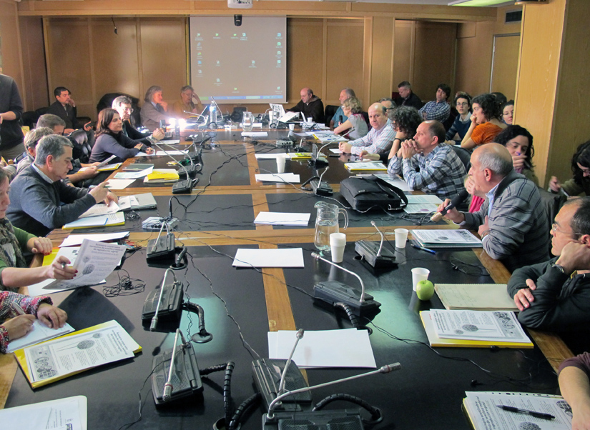  Photo 1. Workshop participants.  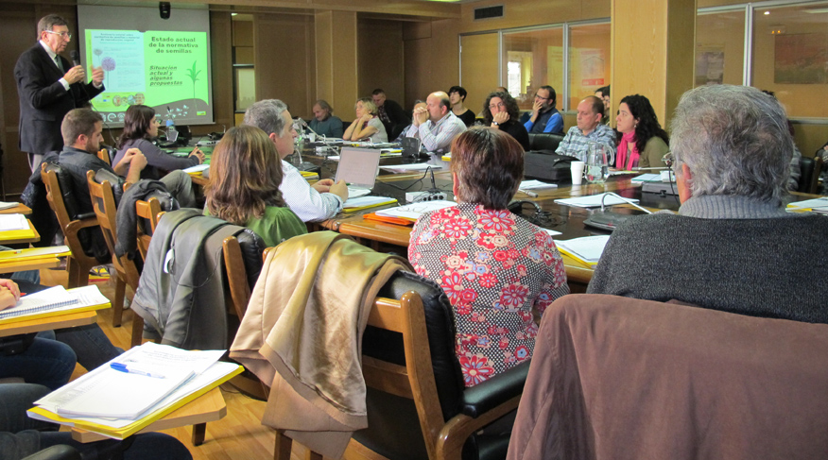  Photo 2. Mr. Pedro Chomé (Subdirección General de Medios de Producción Agrícolas and Oficina Española de Variedades Vegetales of the Ministry of Agriculture).  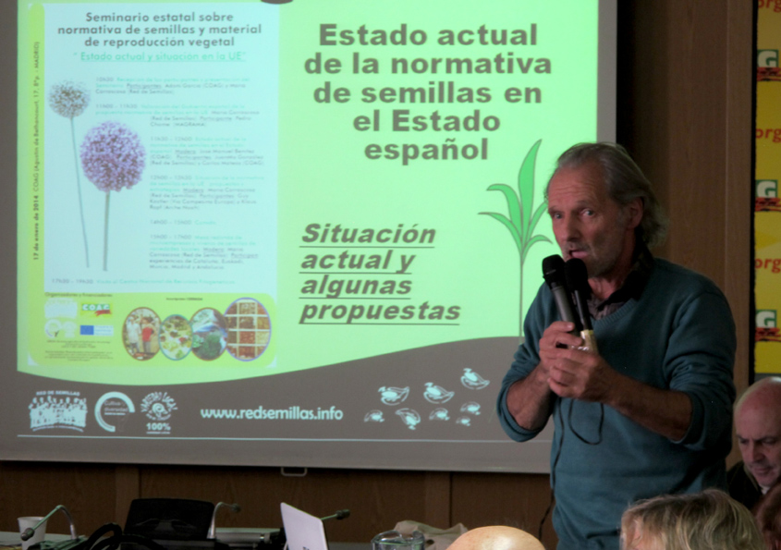  Photo 3. Lecture of Guy Kastler of Réseau Semences Paysannes and Vía Campesina Europe.  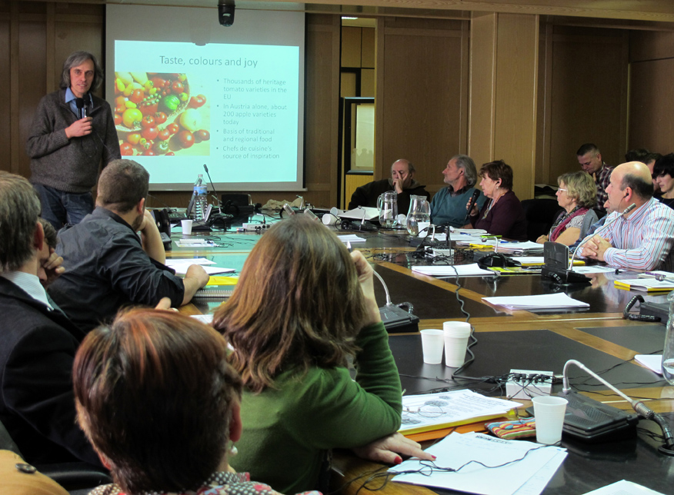  Photo 4. Lecture of Rapf Klaus (Arche Noah).  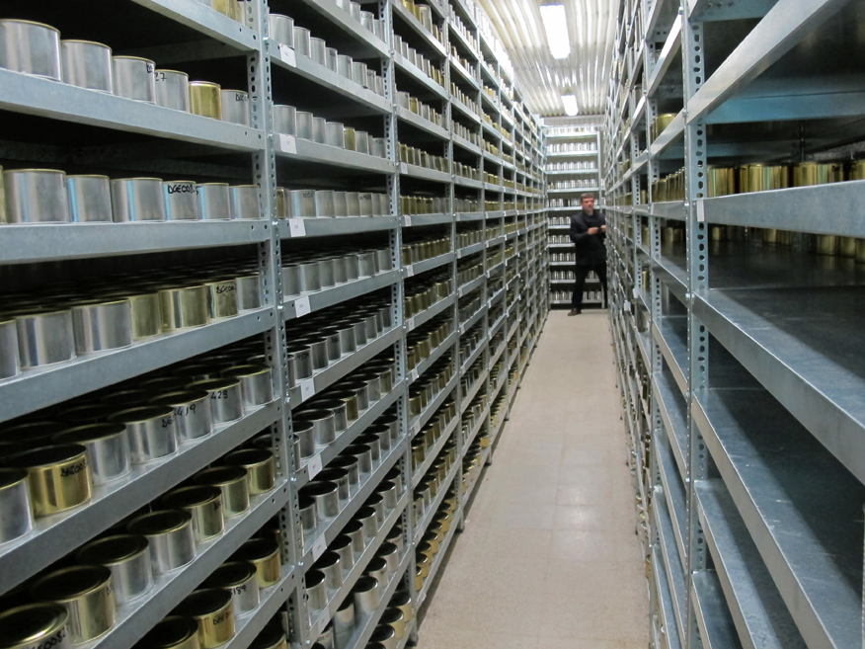  Photo 5. Visit to Centro Nacional de Recursos Fitogenéticos (CRF).  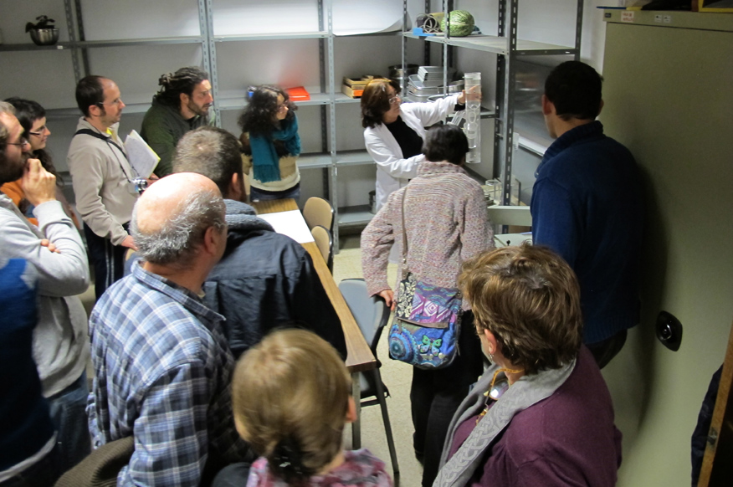  Photo 6. Lecture of Isaura Martín (Centro Nacional de Recursos Fitogenéticos-CRF).

